**TEAM 45**

**PROJECT 2**

**DESIGN NOTEBOOK**

Kathryn Atherton

Joshua Hahn

Hannah Mackin Schenck

**Table of Contents**

|  |  |
| --- | --- |
| Meeting Minutes & Agendas | 3- 4 |
| March 21, 2016 | 3 |
| March 23, 2016 | 3 |
| March 25, 2016 | 3 |
| March 28, 2016 | 3-4 |
| March 30, 2016 | 4 |
| April 1, 2016 | 4 |
| Exploration of Problem & Research | 5-7 |
| March 21, 2016 Update | 5-6 |
| March 23, 2016 Update | 6-7 |
| March 25, 2016 Update | 7 |
| Identification of Key Factors in Model | 8-9 |
| March 23, 2016 Update | 8 |
| March 25, 2016 Update | 8-9 |
| Major Ideas/ Brainstorming | 10 |
| March 21, 2016 Update | 10 |
| Project Management | 11-12 |
| Gantt Chart | 11 |
| Work Breakdown Structure | 11 |
| Project Management/ Workload Distribution | 12 |
| Design Concepts | 13-15 |
| March 23, 2016 Update | 13-14 |
| March 30, 2016 Update | 14-15 |
| Flowcharts & QFDs | 16-17 |
| System Diagram | 16 |
| Model Logic Flowchart | 16 |
| Model of Site | 17 |
| Test Cases, Experiments, and Results | 18-19 |
| Given Test Case | 18 |
| Most Ideal Site 1 Values | 18 |
| Most Ideal Site 3 Values | 19 |
| Decision Matrices | 20 |
| Site and Parts Decision Matrix | 20 |
| March 30, 2016 Update | 20 |
| Alternative Solutions House of Quality | 21 |

**Meeting Minutes**

Monday, March 21, 2016 -- Project Class Day 1

* Agenda:
  + Specifications
  + Research
* Minutes:
  + Project 2 Introduction
  + Accounting in Engineering Lesson & Exercises
  + Documents for Design Notebook, Report, and Poster begun
  + Gantt Chart, Work Breakdown Structure, Workload Distribution Completed
* Electronic Signatures:
  + Kathryn Atherton
  + Joshua Hahn
  + Hannah Mackin Schenck

Wednesday, March 23, 2016 -- Project Class Day 2

* Agenda:
  + Model Refinement
* Minutes:
  + Researched system losses
  + Began a system diagram
* Electronic Signatures:
  + Kathryn Atherton
  + Joshua Hahn
  + Hannah Mackin Schenck

Friday, March 25, 2016 -- Project Class Day 3

* Agenda:
  + Model Design
* Minutes:
  + Research completed on flow rate
  + Code logic framework begun
  + Spreadsheet for most cost-effective solution created
* Electronic Signatures:
  + Kathryn Atherton
  + Joshua Hahn
  + Hannah Mackin Schenck

Monday, March 28, 2016 -- Project Class Day 4

* Agenda:
  + Model Testing Refinement
* Minutes:
  + Spreadsheet completed
  + Model sites analyzed
  + Best site and parts selected from spreadsheet analysis
  + Code framework completed
* Electronic Signatures:
  + Kathryn Atherton
  + Joshua Hahn
  + Hannah Mackin Schenck

Wednesday, March 30, 2016 -- Project Class Day 5

* Agenda:
  + Exploration of Alternatives
  + Preparation for Presentation
* Minutes:
  + Cleaned up code
  + Created House of Quality for Alternative ways to store solar energy
  + Rejected Site 1
  + Determined new best site and parts from spreadsheet analysis
  + Determined best shape and size for reservoir; pump and turbine flow rates
  + Estimated cost, efficiency, and found ratio of cost to efficiency
  + Finalized Poster presentation
* Electronic Signatures:
  + Kathryn Atherton
  + Joshua Hahn
  + Hannah Mackin Schenck

Friday, April 1, 2016 -- Project Class Day 6

* Agenda:
  + Presentation Day
* Minutes:
  + Presented poster and model
* Electronic Signatures:
  + Kathryn Atherton
  + Joshua Hahn
  + Hannah Mackin Schenck

**Exploration of Problem & Research**

*** if there is no source listed at the end of a section, the information is from class ***

Updated March 21, 2016

* Solar Energy Grand Challenge
  + Importance of Solar Energy
    - Fossil Fuels cannot keep up with energy demands
    - Coal creates pollution problems
    - Solar energy can be a long term, clean energy source
  + Efficiency of Solar Energy
    - Today’s photocells are 10 - 20% efficient
    - Implementing these would increase costs by 3 - 6 fold
    - Experimental photocells can be up to 40% efficient
    - Nanocrystal photocells could theoretically be up to 60% efficient
  + Making Solar Energy More Economical
    - New materials to lower fabrication costs
    - Materials must be highly pure
    - Thin materials would be favored to decrease the distance the charges would have to travel
    - Thin materials absorb less sunlight
    - Possible solutions
      * Cylinders to increase surface area in one direction, decrease distance in the other
      * Dye molecules to absorb sunlight and titanium dioxide molecules to absorb the charges
  + Storing Solar Energy
    - Needed for cloudy days, night time
    - Possible solutions:
      * Pumping water to recover the hydroelectric power later
      * Large banks of batteries
      * Capacitors, superconducting magnets, flyweels
      * Mimic biological capture of solar energy
      * Electrolysis of water to create and store hydrogen
      * Fuel cells
  + Source:
    - Make Solar Energy Economical. (n.d.). Retrieved March 22, 2016, from http://www.engineeringchallenges.org/challenges/solar.aspx
* Current Solutions/Options:
  + Pumped Hydro Storage
    - Use the solar energy to pump water uphill to store energy in hydropower reservoirs
    - Basis for pumped storage plants, could be revived with wind and solar energy
    - Used in Japan
    - Source:
      * Fairley, P. (2015, March 18). A Pumped Hydro Energy-Storage Renaissance. Retrieved March 22, 2016, from http://spectrum.ieee.org/energy/policy/a-pumped-hydro-energystorage-renaissance
* Universal Accounting Method
  + Look at initial and final states only; inputs and outputs from outside; additions and subtractions from inside
  + Use Newton’s Laws if what is happening in between or details matter
  + Account for mass, energy, charge, linear momentum, angular momentum, entropy (not conserved)
  + Modeling process:
    - Start with simple estimation
    - Gradually add complexity in stages

Updated March 23, 2016

* Pipe Friction
  + Pipe friction equation: Darcy-Weisbach equation
  + HDW = f * (L/D) * (V^2 / 2g)
  + HDW is additional effective height of pipe (head loss) related to energy lost due to friction in pipe
  + F is friction factor
  + L is length of pipe, D is diameter
  + V is velocity in pipe
  + Combine with potential energy to find energy losses in pipes
  + Source:
    - Hazen-Williams Equation - calculate Head Loss in Water Pipes. (n.d.). Retrieved March 23, 2016, from http://www.engineeringtoolbox.com/hazen-williams-water-d_797.html
* Evaporation Loss
  + Gh = (theta) * A * (xs - x)
  + Gh = amount of water evaporated per hour
  + (theta) = evaporation coefficient -- (25 + 19v)
  + V = velocity of air above water
  + A = water surface area
  + Xs = humidity ratio in saturated air at same temperature as the water surface
  + X = humidity ratio in the air
  + Source:
    - Evaporation from Water Surfaces. (n.d.). Retrieved March 23, 2016, from http://www.engineeringtoolbox.com/evaporation-water-surface-d_690.html
* Pipe Bend Loss
  + Hminor_loss = E v^2 /2g
  + H minor loss = minor head loss (m, feet)
  + E = minor loss coefficient
  + V = flow velocity
  + G = acceleration of gravity
  + Source
    - Minor Loss Coefficients in Pipes and Tubes Components (n.d.). Retrieved March 23, 2016, from http://www.engineeringtoolbox.com/minor-loss-coefficients-pipes-d_626.html
* Cotter’s Method
  + For N factors, only 2 (N + 1) simulations are necessary (linear vs. quadratic), where +1 = high (largest value that parameter could be) and -1 = low (smallest value parameter could be)
  + This helps figure out which is the most important
  + First trial -- set each to low parameters -- output = y
  + Second, make 1 high -- output = y
  + Third, 1st low, 2nd high, all others low -- output = y
  + After all were high once, all high -- output = y
  + All except 1 high, rotate through -- output = y
  + Use Cotter’s method formulas to normalize -- get sensitivity
  + Sensitivity for each parameter vs parameter bar graph
  + Care about the parameters that are larger than 1 / N

Updated March 25, 2016

* Volumetric Flow Rate
  + Q = volume of fluid output by a device per unit time
  + Q = A * v (area of pipe * average fluid velocity)
  + Q = V / t (volume per time) = Ad / t (area * length per time)
  + Dictated by design choice

**Identification of Key Factors in Model**

Updated March 23, 2016

* Storing solar power for later use
  + Storage efficiency (how much energy you get back for the energy put in)
* Obtaining solar power efficiently and economically
  + Energy capacity (MWh)
  + Cost
  + Maximum Power Output
* Key inputs and outputs
  + Inputs:
    - Sunlight inputs solar energy
    - Water -- creates potential energy
  + Outputs:
    - Electrical energy formed by the kinetic energy created by the water falling
* Key losses or gains in the system
  + - Key: considered -- found to be negligible; considered -- found to be significant; not considered/negligible
  + Evaporation
  + Energy loss due to inefficiency
  + Loss due to pipes
  + Rain water
  + Animal/plant consumption of water
  + Tectonic plates cause the height of the upper reservoir to change
  + Animal pee
  + Vibrational energy
  + Heat energy
  + Lightning strikes
  + Water freezing
  + Runoff water
  + Fluctuation in temperature
  + Sound in turbine spinning
  + Friction in pipes
  + Bends in pipes
  + Damage to equipment
  + Turbulence in water

Updated March 25, 2016

* Issues: Inputs
  + Pipe dimensions (length, diameter) [design choice]
  + Loss coefficients [design choice]
  + Velocities of water in the pipe (Vup, Vdown)
  + Mass of water moved (M)
  + Input Energy (Ein)
  + Height of water in reservoir
* Equations to make solvable!
  + Universal Accounting Equation for mass for filling reservoir
    - Final Amount - Initial Amount = Input - Output + Generation - Consumption
    - Mfinal = Min = p(rho) * Qpum (delta T) --> (density * Volumetric flow rate (m^3 / s) * filling time)
    - Pressure = p(rho) * g * h

**Major Ideas/ Brainstorming**

Updated March 21, 2016

* In-Class: Methods to Address Issues with Obtaining/Storing Solar Energy
  + Rechargeable Batteries -- chemical energy
  + Molten salt
  + Photosynthesis
  + Solar Oven
  + Steam
  + Springs
  + Weights
  + Hydrogen Fuel Cells
  + Solar Power Generator that passively stores charge
  + Solar panel satellite that is always exposed to sunlight

**Project Management**

Gantt Chart -- Updated March 30, 2016

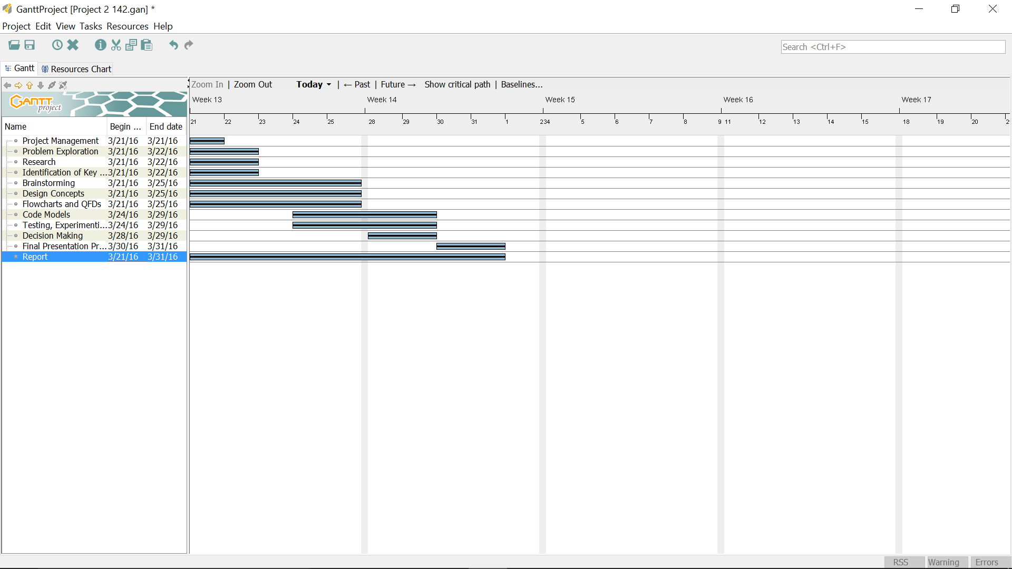

Work Breakdown Structure -- Updated March 21, 2016

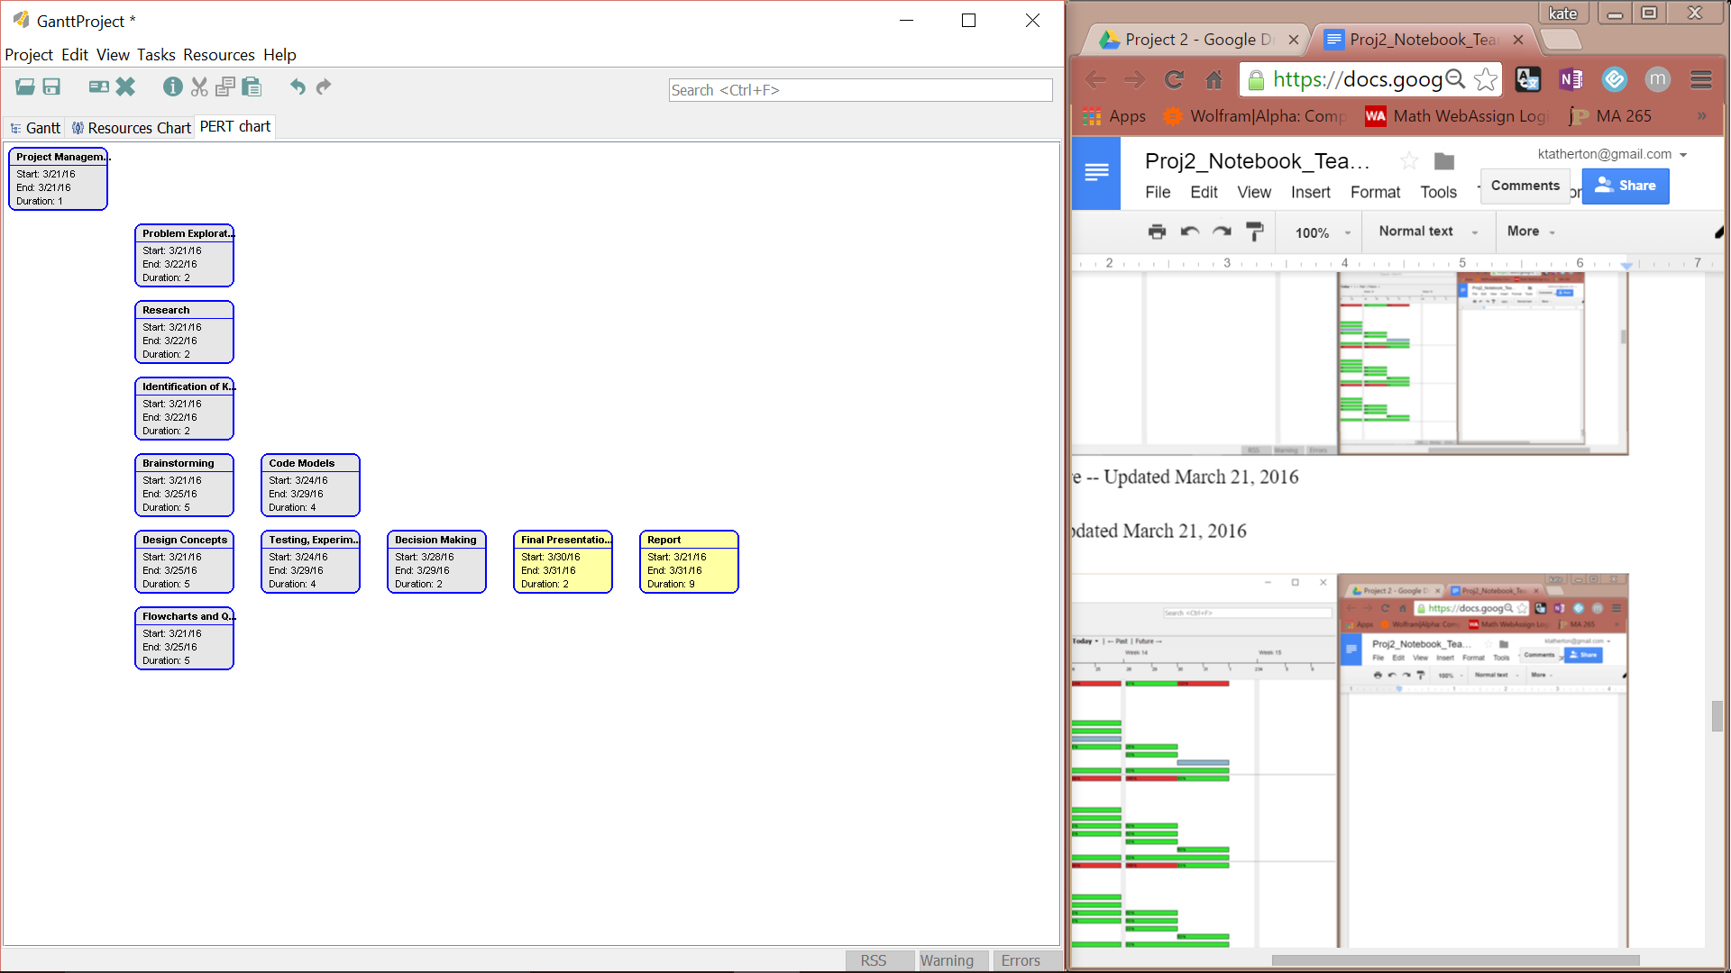

Project Management -- Updated March 21, 2016



**Design Concepts**

Updated March 23, 2016

* Define the system:
  + Boundary used for accounting for conservation of mass and energy for system
* Electrical energy enters a power plant and is used to raise a mass M of water into a reservoir height H above the plant, all is run through a turbine
  + Ignore all possible losses, create a system representation
* Mass or energy goes besides where we want it
  + Find the efficiency of the system: ratio of work done over energy put in
    - Always between 0 and 1
  + Consumed energy eventually escapes the system boundaries
    - Not an output: treated as consumption
  + Turbines are 80-90% efficient
    - 30% of energy is lost due to consumption
* Select losses or gains -- estimate creation/consumption of energy and mass -- are the factors important/significant?
  + Pipe friction
    - E(in;w) - E(in;w/o) = M * [(fLV^2 / 2D) + h]
  + Evaporation loss
    - Gh = (25 + 19v) * A * (xs - x)
    - Xs = 0.015
    - X = 0
    - V = 2.5m/s
    - Using equation -- lose 0.26% of the reservoir per day -- not very significant
  + Leaks in pipes or reservoir
    - Very small
    - Difficult to estimate
    - Likely to be noticed quickly if significant
  + Bends in pipes
    - Hminor_loss = E v^2 /2g
    - E = 1
    - V = 20 m/s
    - G = 9.81 m/s^2
    - Hminor_loss = 20.4 m
    - Significant!! -- include in model
  + Rain water
    - Average per day = 0.0044 m / m^2 day
    - 0.04% / day
    - Insignificant!! Ignore in model
* Language used:
  + C
    - Better than Python for handling data
    - Most recently worked with in class; most familiar to team

Updated March 30, 2016

* Site and Parts decided upon (see page 18)
* Reservoir shape, size, and pump/turbine flow speeds must be decided upon
  + Reservoir shape: circle will be used as this allows for a large area-to-perimeter ratio to maximize the area that will be used while minimizing the cost of the wall surrounding the reservoir
  + Reservoir size: determined by code, depends on the pump flow speeds
  + Pump/Turbine flow speed: the team desires that the fill time be approximately 8 hours, as there is an average of 8 hours of sunlight per day in the USA-- this will minimize the solar energy wasted due to the reservoir remaining full during daylight hours; thus the team desires that the empty time be approximately 16 hours, so that the reservoir empties overnight and maximizes the energy produced during a high-demand time for the solar energy
    - Using trial and error by substituting various flow speeds into the code, the optimal pump flow speed was determined to be 25 m^3/s and the optimal turbine flow speed was determined to be 15 m^3/s. This makes the fill time to be 7.67 hours and the empty time to be 12.79 hours.
* Efficiency:
  + The efficiency of the system given the values determined (see above bullet point and Decision Matrix on page 20) is 70%
* Cost Estimation: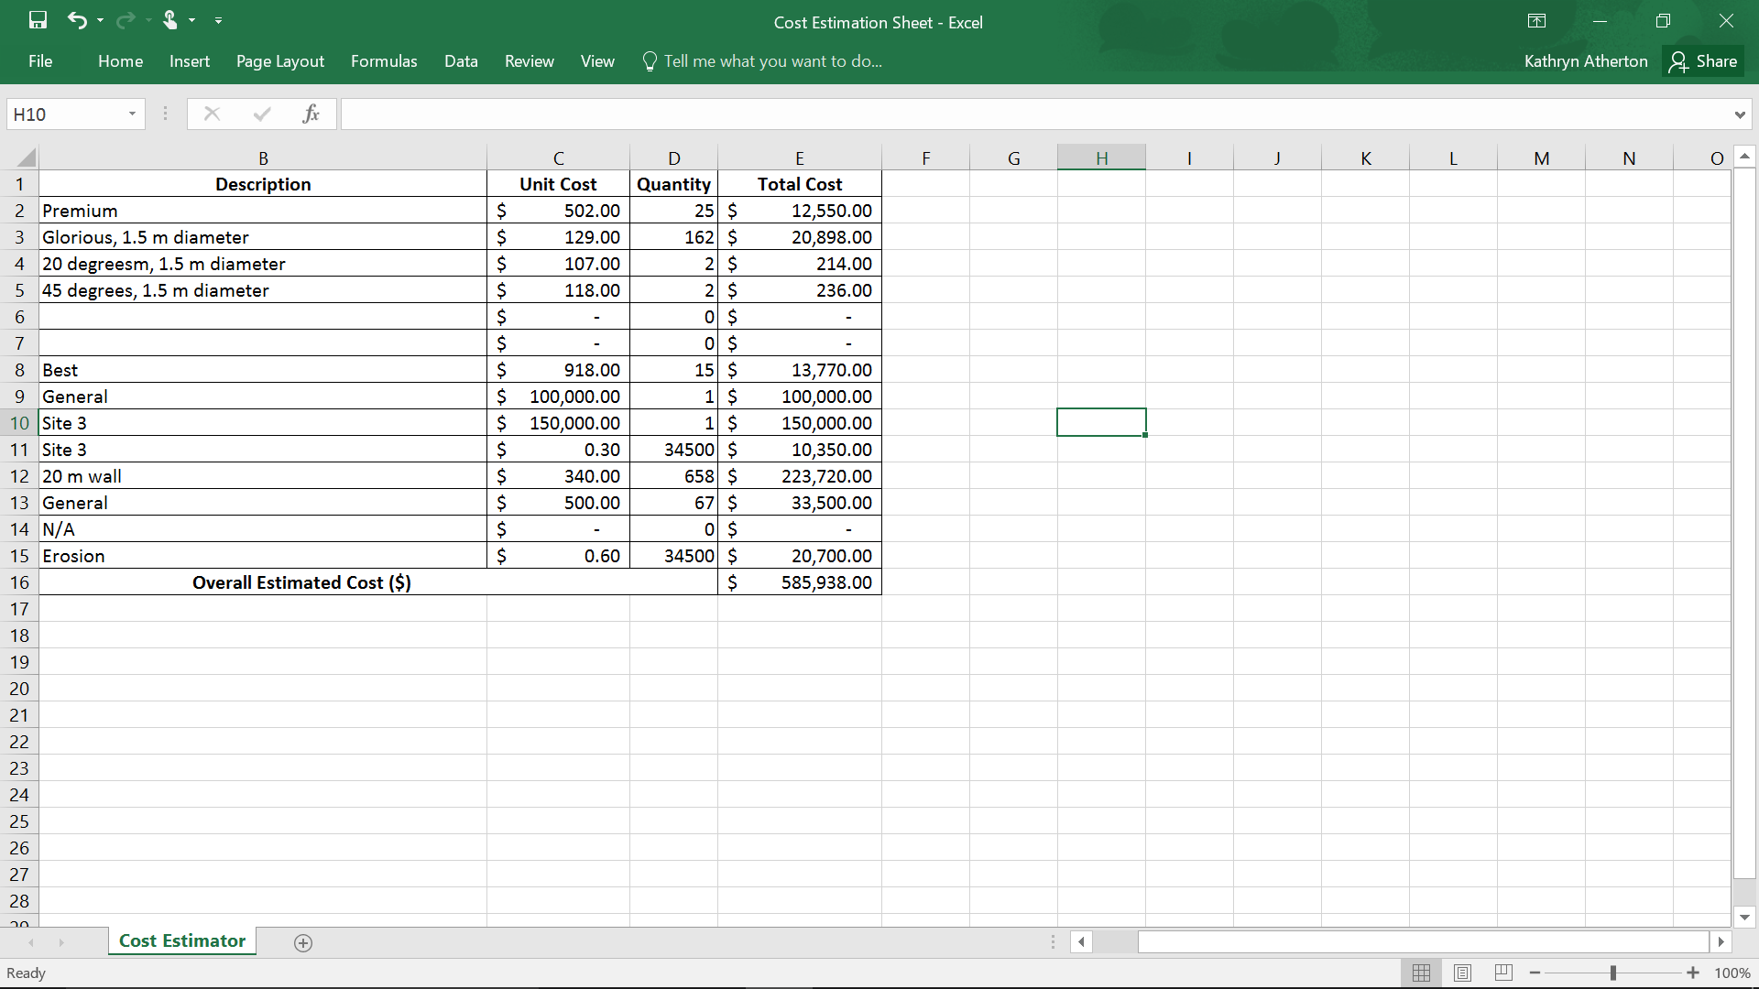
* Cost-to-Efficiency Ratio:
  + $585938/70 = $8370.54

**Flowcharts and QFDs**

System Diagram -- Updated March 23, 2016

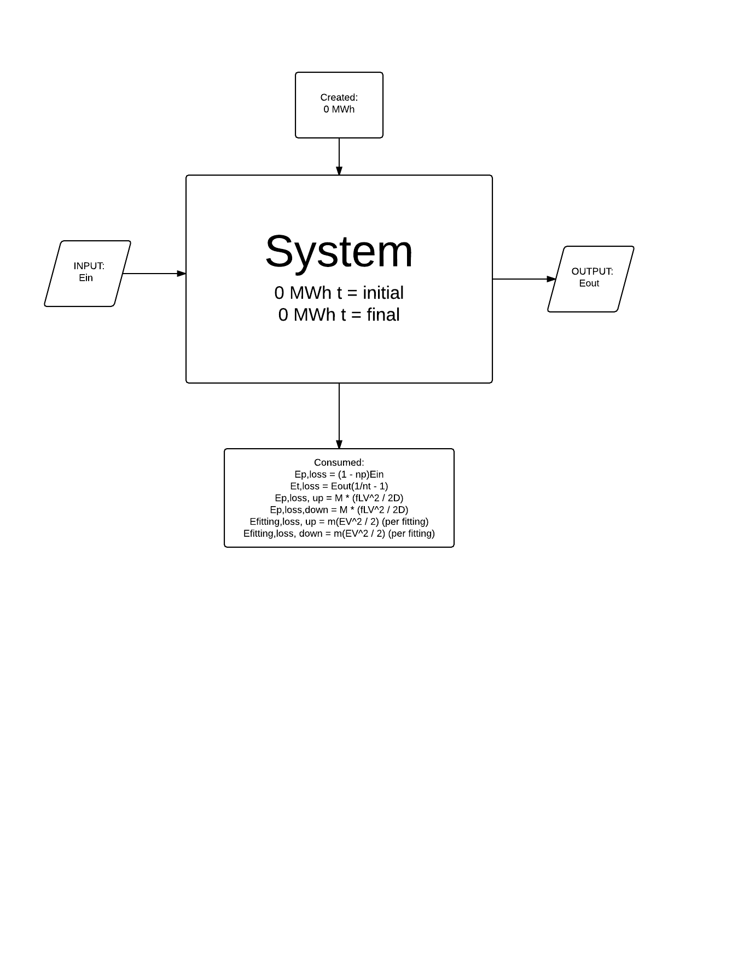

Model Logic Flowchart -- Updated March 28, 2016

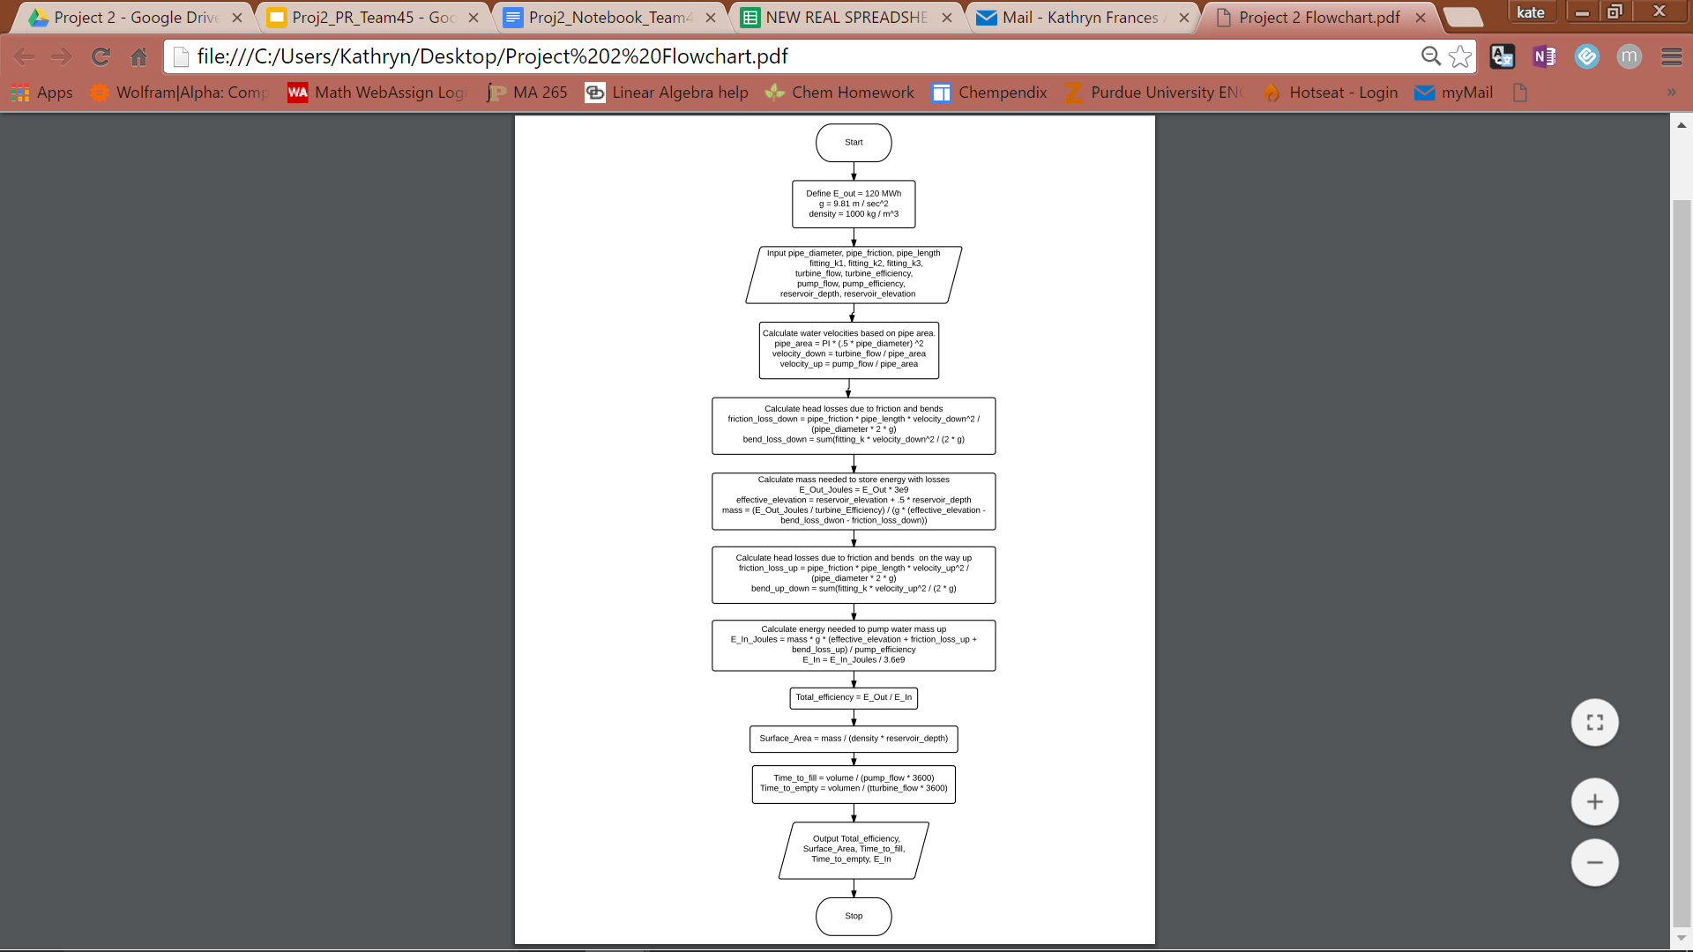

Model of Site -- Updated March 30, 2016

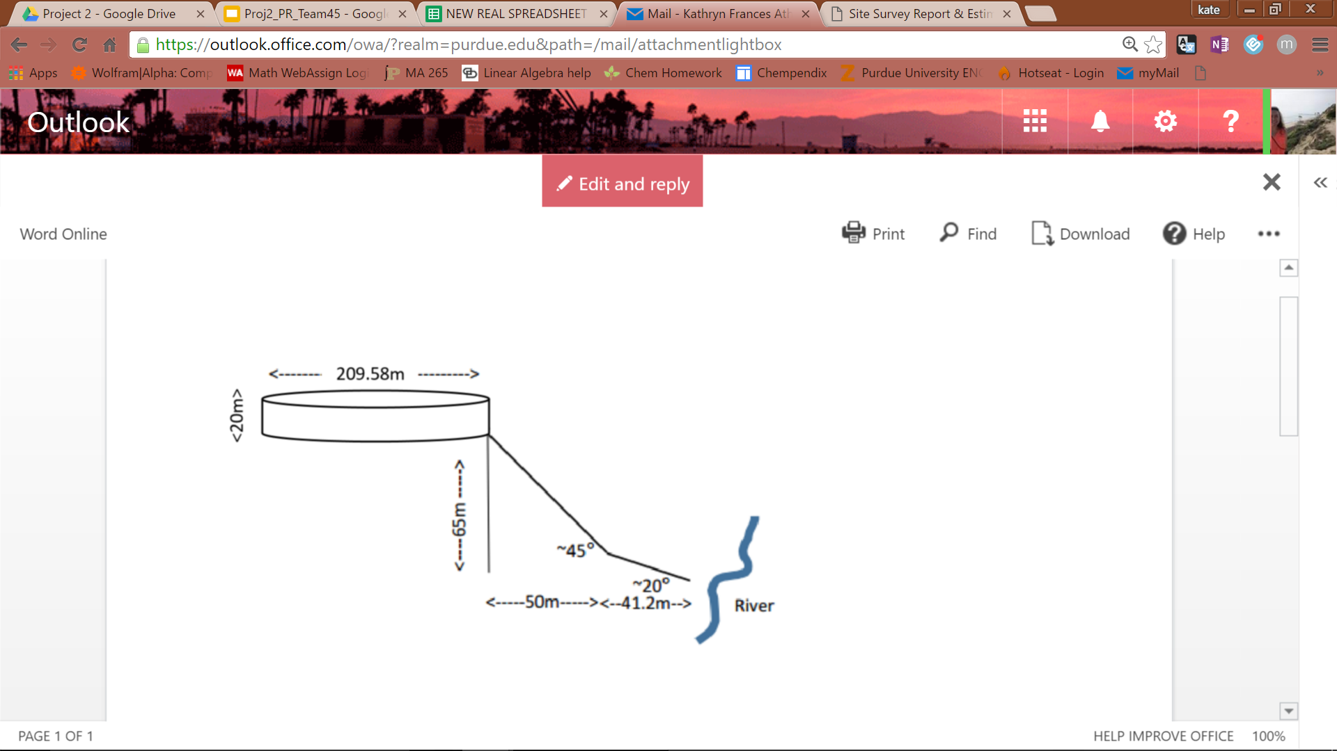

**Test Cases, Experiments, and Results**

Given Test Case -- Updated March 28, 2016

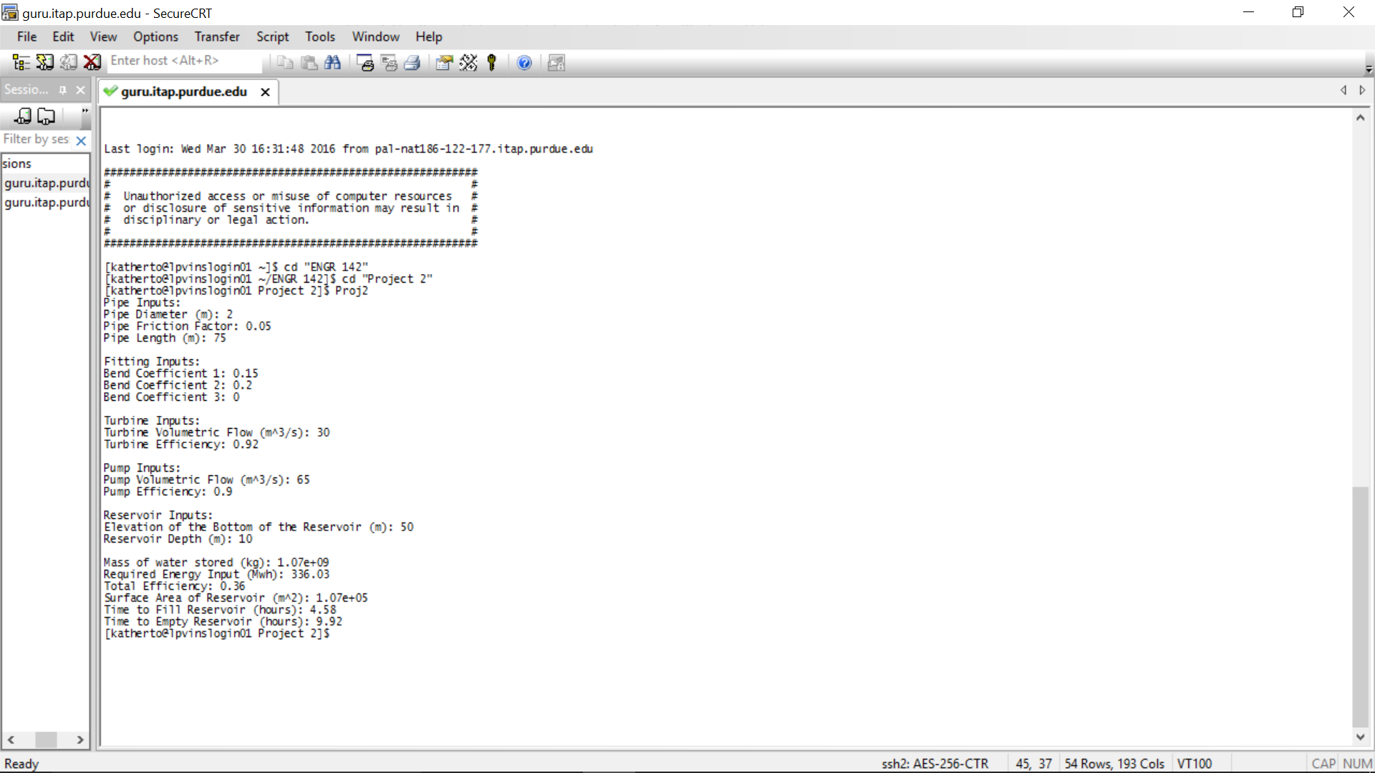

Accurate: therefore, code works properly

Most Ideal Site 1 Values (see page 20) -- Updated March 30, 2016

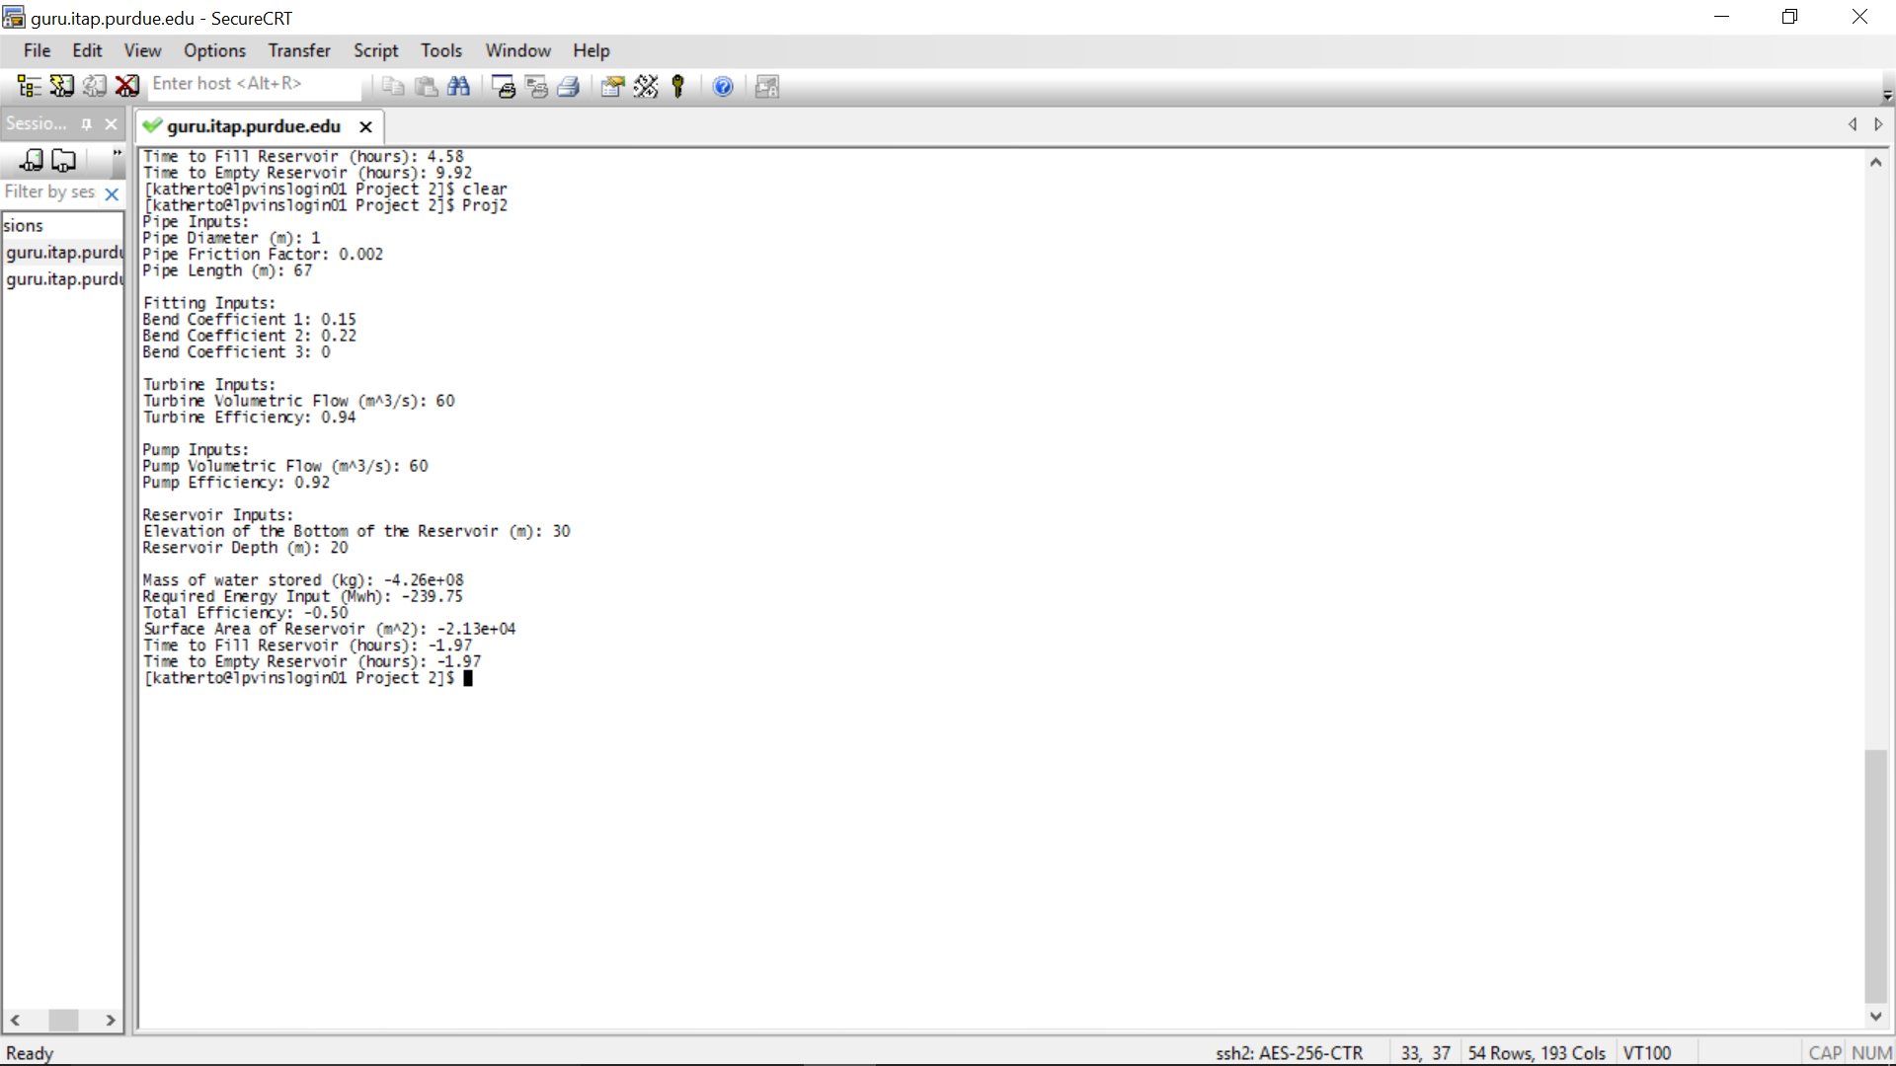

Negative Values: therefore, site 1 is rejected

Most Ideal Site 3 Values -- Updated March 30, 2016

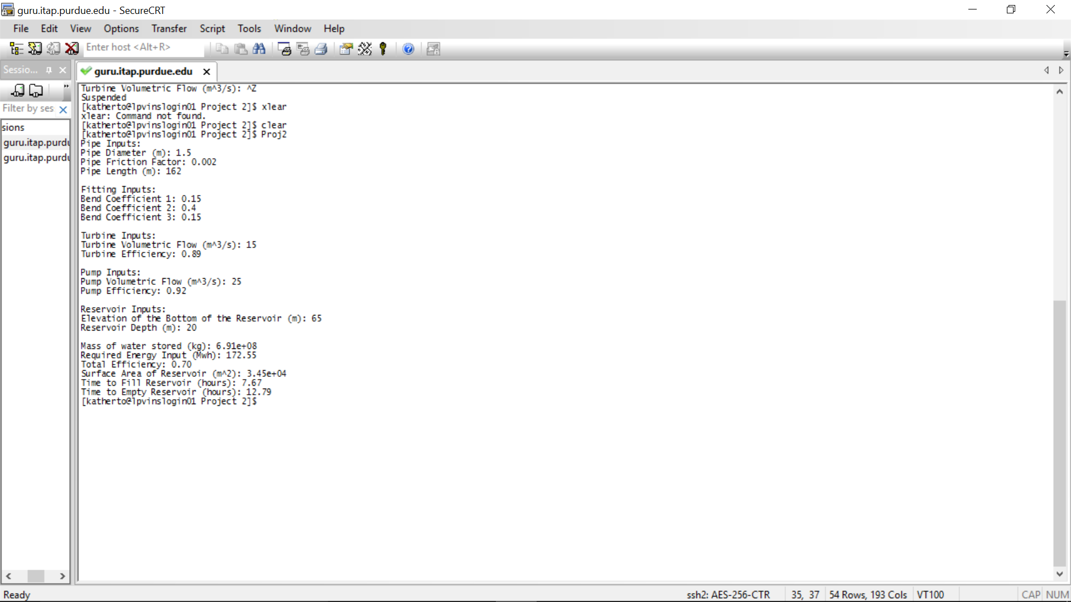

**Decision Matrices**

Site and Part Decision Matrix -- Updated March 28, 2016

A decision matrix was created to help determine the most cost-effective site and parts for use in model. Below is a very small section of it, as it is impossible to fit a screenshot of the entire matrix within this design notebook.

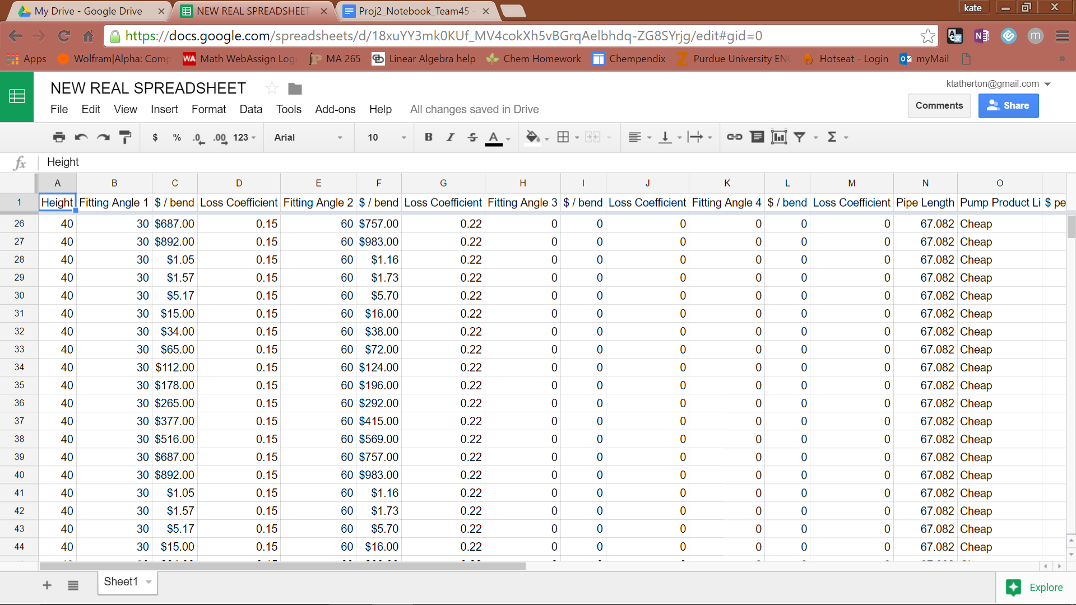

To create the matrix, the team determined the optimal design for each site, choosing the fitting angles and pipe lengths for each site. The team then entered the data for the site-specific costs and dimensions, including site preparation costs, height, fittings, and pipe length into the decision matrix and then created iterations for every possible design option with the pumps, turbines, and pipes with consistent assumptions for the amount and velocity of water and the assumption that all the land available would be used. The matrix determined the overall energy loss by the system, the cost of each design option, and the ratio of the cost to the loss. The option that had the least energy loss was at site 1 with the Premium pump, Mondo turbine, and Glorious pipes with a diameter of 3 m. The cheapest option was at Site 2 with the Cheap pump, Good turbine, and Salvage pipes with a diameter of 0.1 m. However, the option that had the lowest cost to loss ratio was at Site 1 with the Premium pump, Mondo turbine, and Glorious pipes with a diameter of 1 m.

Updated March 30, 2016

After running the above conditions through the code model, it was determined that, while the options decided upon had the lowest cost-to-loss ratio, the losses at pump flow rates that would make the system practical are greater than the energy provided by the height. Since this is the best option for site 1, the site was rejected and the other two sites were considered. Site 2 was rejected due to the social impact that moving the possible Native American burial sites may have. Therefore, site 3 was decided upon. The option with the lowest cost-to-loss ratio at site 3 uses the Premium pump, Best turbine, and Glorious pipes with a diameter of 1.5 m.

Alternative Solutions House of Quality -- Updated March 30, 2016

